Title of your thesis: Step Optimization in Thermal Simulation with PINNS: Selective FEM Step Skipping Methodology
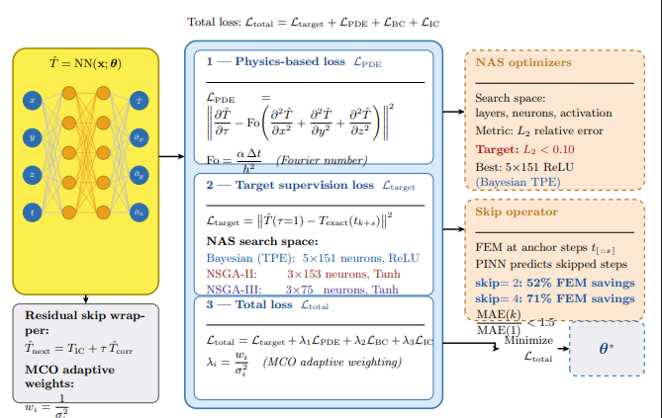
Short summary of your thesis (figure is optional):
In this thesis, we develop a physics-informed neural network-based framework for solving computationally expensive transient heat transfer and quenching problems in a faster, more adaptive, and physically consistent manner. In this project, we aim to combine the high accuracy of classical numerical methods with the speed and flexibility of data-driven models. Accordingly, rather than building a model that only predicts the temperature field, we also focus on identifying suitable network architectures, reducing unnecessary computations during the solution process, and directly embedding physical constraints into learning.
In this project, we particularly address the balance between accuracy, stability, and computational efficiency so that physics-informed neural networks can be used more practically in engineering applications. The proposed approach is designed to allocate more computational effort only to critical time intervals or physically challenging regions, while reducing the computational burden in simpler parts of the problem. In this way, the study aims to move PINN-based methods beyond a purely theoretical research tool and toward a reliable simulation framework that can be applied to complex thermal processes and different geometries.
Name of collaboration companies (optional):
ALUDYNE NORWAY AS
Why is your work relevant for the Process Industry:
Our work is highly relevant to the Process Industry because many industrial operations, such as heat treatment, quenching, casting, and other thermal manufacturing processes, rely on accurate prediction of transient temperature fields. However, conventional numerical simulations are often computationally expensive and therefore not well suited for fast decision-making or repeated process optimization. In this project, we develop a physics-informed and computationally efficient framework that reduces simulation cost while preserving physical consistency. This is valuable for the Process Industry because it can enable faster process design, better control of thermal cycles, less trial-and-error, improved product quality, and lower energy and computational costs. Moreover, the adaptability of the proposed approach to different geometries and operating conditions makes it especially promising for real industrial applications, where processes are complex, dynamic, and time sensitive.
Name and email (and phone number) of the master student:
Name of the master program:

